How to use Git
After you change/create/modify new files. You have to use GIT to commit the files and update to the cloud.

Step 1:
Right click your mouse and press “Git Bash Here”
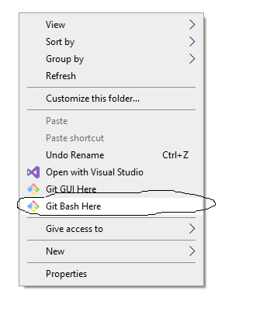

Step 2:
Use command git pull to download all new files.
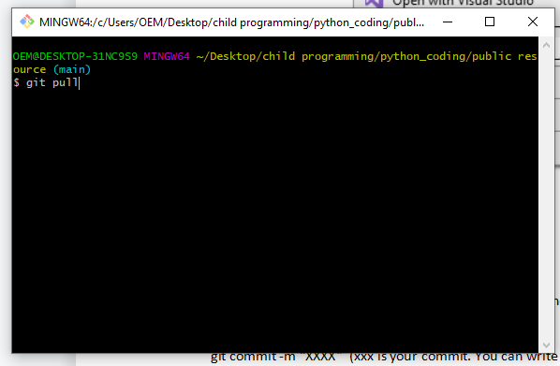

Step 3:
Use command: git add XXXX (xxx is your modify file)
If you have multiple files you need you add all of them one by one.
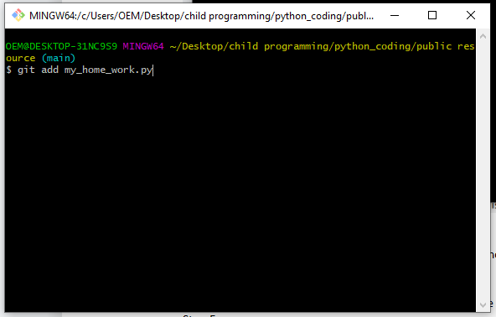

Step 4:
git commit -m “XXXX” (xxx is your commit. You can write like “this is my homework”)
Step 5:
“git push” to update the new files to the web
